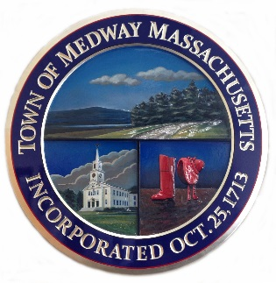

Town of Medway

Commonwealth of Massachusetts

Returning Sunshine Employee 2025

- I need to change my Federal W-4 Tax Withholding ______Yes ______No

If yes, please complete this form
https://storage.googleapis.com/juniper-media-library/117/2024/12/fw4.pdf

- I need to change my State M-4 Tax Withholding ______ Yes _______No

If yes, please complete this form https://www.townofmedway.org/human-resources/files/m4

- I need to change my Direct Deposit Information from Last Year ______ Yes _______No **

If yes, please complete this form and return it with a voided check or bank-issued direct deposit form.
https://storage.googleapis.com/juniper-media-library/117/2024/08/direct_deposit_agreement_form.pdf

_______ Initial I have been provided with the Town of Medway’s Personnel Policy.
https://storage.googleapis.com/juniper-media-library/117/2025/02/medway_personnel_policy_8-2024.pdf

______________________________ ____________________________ __________________
Print Name Signature Date

**Failure to provide correct payroll information will result in an unavoidable delay in payroll processing.

